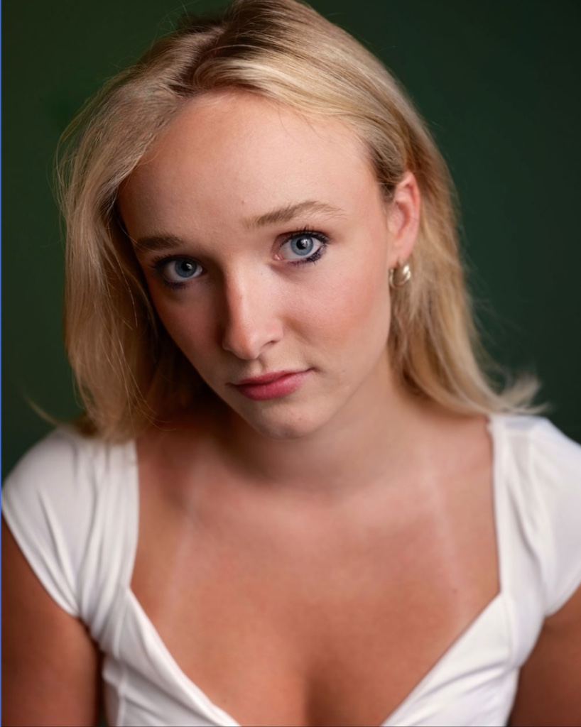
LILY JO WALTERS
LILY JO WALTERS
Location – South-West England, London, New York City,
Height – 5’7
Eye colour – Blue
Hair colour – Blonde
Spotlight - https://app.spotlight.com/3415-6724-7450

CONTACTS
TEL- +44 07535 422293 (UK) +1 34784 29438 (US)
EMAIL- lilywalters545@gmail.com.

CREDITS

THEATRE
Don’t Call Me Blondie, Riley, Echoism Productions (Camden Fringe), dir Belle-Anne Daly Morgan
Out of Sorts, Alice, Tower Theatre, dir Ozlem Taz
Small, Annie, Oxford School of Drama

SHORT FILM
The Space Between, Daliah, dir Sensi CBK
Girls Bathroom, Anna, UCA dir Shawn Gouevia
A Fizzy Felony, Sarah, Infinate Productions, dir Andrew Everheart
Judging Frame, Sara, NYFA, dir Nicolas Gallegos- Anda

MUSIC VIDEO
Motion Sickness, Liv, dir Ella Graves, Maura Mae

COMMERICAL
Conflicts available under request

TRAINING
Stella Adler Studio of Acting, 3-year conservatory
Oxford School of Drama, foundation course
National Youth Theatre member
National Youth Theatre Advanced acting for screen
LAMDA acting short course
Guildhall School of Music and Drama acting short course
Guildford School of Acting – weekly acting classes
LAMDA awards Bronze and silver
SKILLS
Dialect- Native - RP, Sussex, Standard-American
Duel citizenship/ nationality– British, South-African
Instruments – Acoustic and Electric Guitar (intermediate)
Sports- Swimming (advanced), Golf (intermediate), Yoga (intermediate/ advanced),
Netball (advanced), Hockey (field) (advanced), Athletics (long jump intermediate, sprinting, intermediate), Rounders (intermediate).

Other
Manual car driving licence, valid British-passport, valid South-African passport

